Experiment No-02 -GUI operating system and File extensions

OBJECTIVE

- To become Familiar with Graphical user Interface, Operating systems and different file extensions.

INTRODUCTION

GUI (Graphical User Interface):

In computing, a graphical user interface GUI, sometimes pronounced gooey is a type of user interface that allows users to interact with electronic devices with images rather than text commands. GUIs can be used in computers, hand-held devices such as MP3 players, portable media players or gaming devices, household appliances and office equipment. A GUI represents the information and actions available to a user through graphical icons and visual indicators such as secondary notation, as opposed to text-based interfaces, typed command labels or text navigation. The actions are usually performed through direct manipulation of the graphical elements. The term GUI is historically restricted to the scope of two-dimensional display screens with display resolutions able to describe generic information, in the tradition of the computer science research at the PARC (Palo Alto Research Centre). The term GUI earlier might have been applicable to other high-resolution types of interfaces that are non-generic, such as video games, or not restricted to flat screens, like volumetric displays.

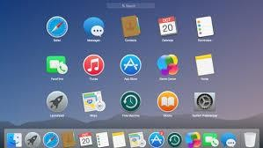
Figure 14 Graphical User Interface

OPERATING SYSTEM:

An operating system (OS) is software, consisting of programs and data that runs on computers manages computer hardware resources, and provides common services for execution of various application software. The operating system is the most important type of system software in a computer system. Without an operating system, a user cannot run an application program on their computer, unless the application program is self-booting. For hardware functions such as input and output and memory allocation, the operating system acts as an intermediary between application programs and the computer hardware, although the application code is usually executed directly by the hardware and will frequently call the OS or be interrupted by it. Operating systems are found on almost any device that contains a computer—from cellular phones and video game consoles to supercomputers and web servers. Examples of popular modern operating systems include BSD, Linux, Mac OS X, Microsoft Windows, and UNIX.

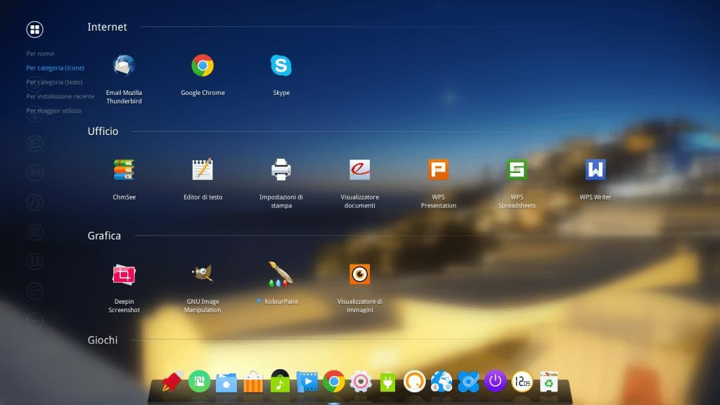
Figure 15 Linux Operating System

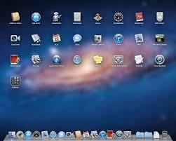

Figure 16 MAC operating system

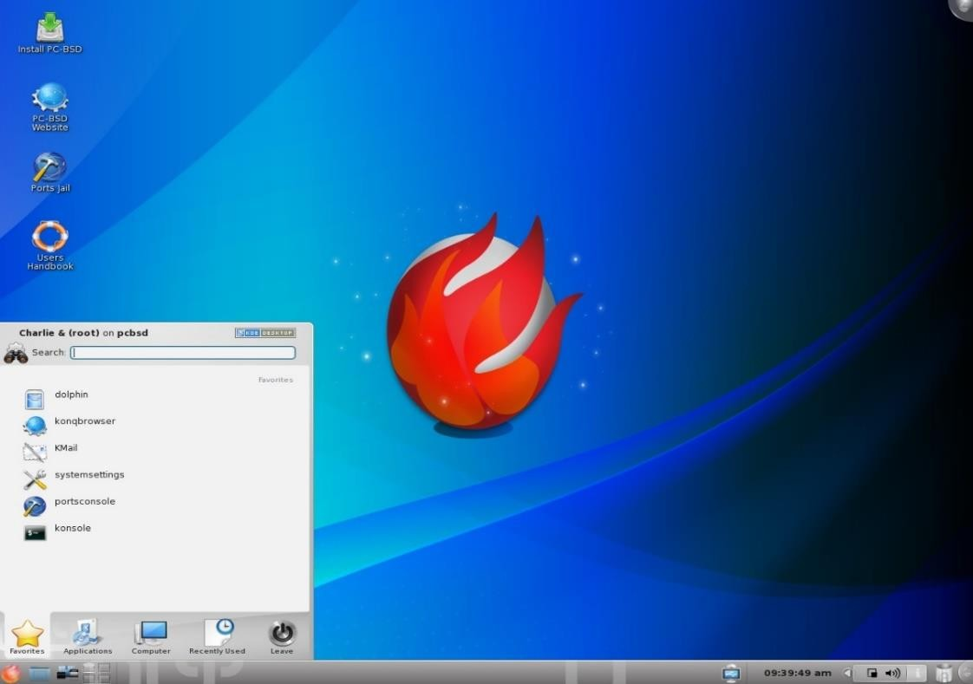

Figure 17 BSD operating system

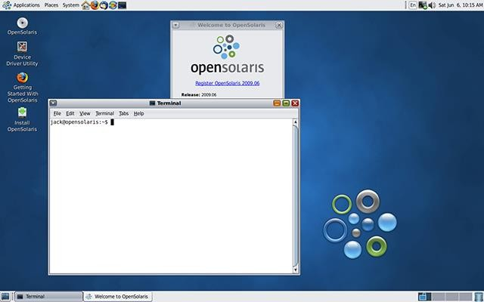

Figure 18 Unix Operating System
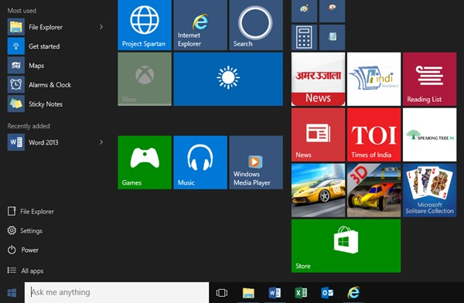

Figure 19 Windows Operating System

FILE EXTENSIONS:

A filename extension is a suffix to the name of a computer file applied to indicate the encoding convention (file format) of its contents. In some operating systems (for example UNIX) it is optional, while in some others (such as DOS) it is a requirement (it may be empty but it always exists). Some operating systems or rather their native or default files systems limit the length of the extension (such as DOS and OS/2 using FAT file system not allowing more than three characters) while others (such as Unix) do not. Some operating systems (for example RISC OS) do not use filename extensions. UNIX accepts the separator dot as a legal character but does not give it a special recognition on the OS level. A file extension is a way of showing the type of a computer file, and a clue to what program it should be opened with. File extensions are usually three letters long and come after the name of the file. Some examples of common file extensions are:

TXT files are plain text files
JPG are picture files in the JPEG format
MP3 are music files in the MP3 format
MPEG are motion picture encoded video files
HTM or *HTML are Hyper Text Markup Language files such as web pages
PHP are web server scripts which create web pages
ODT are Open Document text files
DOC are text documents in Microsoft Word format
XLS are Microsoft Excel spreadsheet documents
PPT are Microsoft Power Point presentation files
EXE are Microsoft Windows executable program files
DLL are Dynamic Link Libraries, a type of executable file, in MS Windows
ZIP are Compressed files (Lempel Ziff algorithm in an archive)
Z are Unix / Linux compressed files
bz2 are bzip2 block compressed files (very good compression)
jar are Java archive files
JSP are Java server pages files
java are Java source code files
class are Java compiled source code files
oc are Java run-time library files
tar are Unix / Linux tape archive files
sh are Unix / Linux shell script files
awk are Unix C like pattern processing language source code files
sed are Unix stream editor command files
lex are Unix / Linux lexical analyzer C code generator specification files

.c Extensions are C programming language source files
.o Extensions are C programming language compiled files

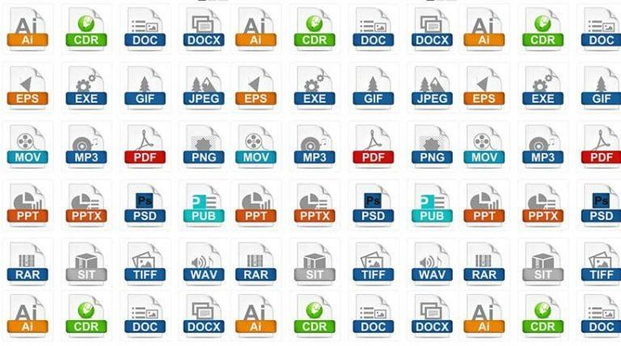
Figure 20 Different File Extensions

TASK:

Take the screenshot of GUI of five different applications and attach with the report.

What is the difference between the file extension:-

doc and docx

jpg and jpeg

Conclusion:

